|  |
| --- |
| **System Installation Design**  **Principles (SIDP)**  **TITLE**  **PROGRAM** |
|  |

|  |
| --- |
| This SIDP is the responsibility of the Program Chief Engineer for use, as reference, by all organisations for the establishment of the Definition Dossiers (Drawings and Associated Documents such as Technical Specifications/ Standards).  SIDP shall be used for installation design.  Never refer to the SIDP in the Definition Dossier (Drawings and Associated Documents such as Technical Specifications/ Standards). |

|  |
| --- |
| The content of this document is the property of Airbus. It is supplied in confidence and commercial security on its contents must be maintained.  It must not be used for any purpose other than that for which it is supplied, nor may information contained in it be disclosed to unauthorised persons. It must not be reproduced in whole or in part without permission in writing from the owners of the copyright.  © Airbus 2014. All rights reserved. |

|  |
| --- |
| Confidentiality .  Distribution of SIDPs to Suppliers is subject to CoC authorization with a confidentiality agreement. |

|  |
| --- |
|  |
|  |

|  |  |  |
| --- | --- | --- |
| Responsible Approval. (signed)  Date.  Name. Aaaa AAAA  Function. SIGLUM |  | Authorization. (signed)  Date.  Name. Bbb BBBBB  Function.SIGLUM |

# Introduction

## Purpose

The aim of an SIDP document is to provide optimal and harmonized installation design principles that first comply with the system requirements (TDD and/or SIRD) and take into consideration weight saving, cost of production and maintenance aspects for the whole aircraft.

In SIDP, the design principles are divided into Mandatory Design Principles and recommendations. The MDP shall be identified with this format.

The mandatory design principles identified in the SIDP and listed in appendix 7.11 will be submitted to the V&V process.

## Definitions

The use of "shall", "should", "must", "will" and "may" within this SIDP shall observe the following rules.

* The word SHALL in the text denotes a mandatory design principle of the SIDP to be applied. Departure from such a principle is not permissible without the formal agreement of the SIDP Responsible and System Responsible (e.g. TDD Responsible, System designers, DCS).
* The word SHOULD in the text denotes a recommendation or advice on implementing principles defined in the SIDP. Such recommendations or advice are expected be followed unless good reasons are stated for not doing so.
* The word MUST in the text is used for legislative or regulatory requirements (e.g. Airworthiness or Health and Safety) and shall be complied with. It is not used to describe a principle defined in the SIDP.
* The word WILL in the text denotes a provision or service or an intention in connection with a principle defined in the SIDP.
* The word MAY in the text denotes a permissible practice or an alternative action in connection with a principle defined in the SIDP.

## Nomenclature/Abbreviation

* A/C Aircraft
* ATA Air Transport Association

## Document Precedence

Where conflict exists between this document and any of the referenced documents with regard to a safety related issue, guidance shall be formally requested from the System Responsible (e.g. TDD Responsible, System designers, DCS).

# Objectives

The objectives of this SIDP are common to all other SIDP documents.

* Define the design principles for a given aircraft project.
* Assure harmonization of standard items and design principles across aircraft projects.
* Consider experience and customer support aspects.
* Provide a reference for engineering quality monitoring.
* Provide a reference for design evolution monitoring (design reviews).
* Record technical decisions and best practice applicable to an aircraft project.

# Reference Regulations/Documents

## Airworthiness Regulations

* JAR 25.607 Fasteners
* REF Title

## Others

* A350XWB_SIDP V&V Policy PL0901917

# Responsibilities

Structures CoC is responsible for the production and maintenance of this SIDP in accordance with the System Responsible (e.g. TDD Responsible, System designers, DCS) and Program requirements.

The Program Chief Engineer is responsible for authorization of this SIDP and therefore validates its use on the aircraft program.

The responsibility for determining the suitability of the standard design principles described in this document for specific installations shall lie with the specific design teams deployed on the program.

# Structures/Systems Configuration

The whole A/C is affected by this SIDP.

# Application Domain

ATA 92, ATA 53, ATA 54, ATA 55, ATA 56 and ATA 57 are affected by this SIDP.

# Design Principles

## Design Principles Applicable to the Entire Design

**General**

SIDP92A001V-A-269

*The effects of thermal variations, structural deformation, pressurization variation, etc., shall be taken into account*.

SIDP92A001V-A-280

*Each item in direct contact with ATA92 bundles shall be qualified to withstand conditions detailed in Table 3 below.*



Table 3. Operating conditions for items in direct contact with ATA92 bundles

*Attachment devices placed inside boxes, which contain power cables, shall withstand.*

*- a minimum of 150°C for peak condition and*

*- a minimum of 110°C for continuous operating condition.*

Sufficient clearance should be provided near connections and attachment points in order to permit easy access (visual check, maintenance operations with standard tools).

**Bolted Fastenings**

SIDP92A001V-A-356

*Bolts shall be capable to resist applied mechanical loads. The screw diameter, specified in the standard of the to be attached component, shall be used as first priority.*

**Locking Of Bolted Fastenings**

SIDP92A001V-A-413

*In vibration area all electrical items and equipment shall be tightened and locked with.*

*- Self-locking device*

*- Lock wire.*

SIDP92A001V-A-424

*All active screw (electrical active functions) shall be locked by.*

*- Lock wire or*

*- Self-locking device (e.g. NSA5050).*

**Installation In Ceiling Area**

SIDP92A001V-A-3763

*When electrical installation on*

*- A/C shell (skin and stringer) or*

*- frames*

*cannot be avoided between stringer P18, P0 and P18', the attachment concept shall be compliant with design principles detailed in SIDP21A004V.*

**Installation In Fuel Tanks**

SIDP92A001V-A-472

*Inside fuel tanks, the components used shall be qualified for continuous fuel immersion.*

### Positioning of Bundles in the Aircraft Considering Environmental Constraints

**General**

SIDP92A001V-A-557

*Maximum allowed bundle diameter shall be 50 mm including margin.*

A spare conduit NSA935805 should be provided for M, S routes inside Fuselage in following cases.

* Behind cabin monuments such as galleys, lavatories or Crew Rest Compartments
* Any other area where electrical routing modification leads to high maintenance workload.

SIDP92A001V-A-579

*Contact of Electrical cables/wires with hot temperature items shall be avoided.*

When bundles are routed through structural holes, the diameter of structural hole should allow the free passage of the bundle/connectors.

### Segregation or Clearances of Bundles to A/C Structure, other Systems or Between Routes

#### General Applications

**Sagging (s)**

SIDP92A001V-A-784

*For installation of optical and electrical harnesses additional clearance for sagging (s) shall be provided as detailed below.*



Figure 6. Sagging of bundles between attachment points

*Sagging applies to bundles routed horizontally between -180° to 0° around the bundle axis, except in vertical bundle position.*



Figure 8. Sagging application for horizontal bundles

*A bundle is considered to be in a vertical position if its axis is included in a cone of 15° regarding the vertical A/C axis (Z-axis).*

#### Clearance Values between Bundles and A/C Structure or other Systems

This chapter deals with segregation and clearance requirements between optical and electrical bundles AND adjacent structure or systems.

The following clearance requirements are distinguished.

*- Required Clearance (D)*

*- Sagging (s)*

Each single requirement has to be analyzed and taken into account when applicable.

*Note. A guidance for calculation of clearances can be found in* ***Appendix E****.*

**Failure Mode "Loss Of One Attachment Point" (LOAP)**

SIDP92A001V-A-809

*For installation of electrical harnesses the Loss of one Attachment Point shall be considered in accordance with table below.*



Table 11. Required minimum safety clearance (D) after the loss of one attachment point

*After loss of one attachment point and in consideration of sagging (s) the clearance (D) as detailed in the table below shall be met.*



Figure 12. Failure mode "Loss of one attachment point" in horizontal direction

*Note. For non-pre-stressed bundles, loss of one attachment point shall be considered 0 to 180º downwards for horizontal routing.*

*G-routes installed with G-route bobbin.*

*EXCEPTION. the attachment principle of G routes fixed with G-route bobbin a is a mean to take the "Loss of one Attachment Point" into account.*

*This exception is not applicable to G routes in bobbin installed in FFLZ or adjacent to fuel tank walls.*

SIDP92A001V-A-9039

*Loss of an attachment point rules shall be considered on Q routes and adjacent harnesses in all areas. After failure the remaining distance shall be greater than or equal to 10 mm.*

#### Clearances Values between Bundles

*Definition. Terms used in the following*

*- "Open" means that the bundle is not protected by any mean.*

*- "OS" means that the bundle is protected by EMI Open Sleeve (e.g. EN4674, ABS2418).*

**

Figure 16. Definition of criteria "Facing" and "Not facing"

SIDP92A001V-A-850

*Where 2 or more bundles (not applicable to G-, X-, P-, E, 1D and 2D-routes) with.*

*- Different route numbers (e.g. 1M and 2M) and /or*

*- Different route categories (e.g. 1M and 1S)*

*are connected to an equipment using the same connection element (e.g. connector), a co-routing is allowed just before the connection, under following conditions.*

*- An attachment device is provided at the end of the co-routing as detailed in figure below.*

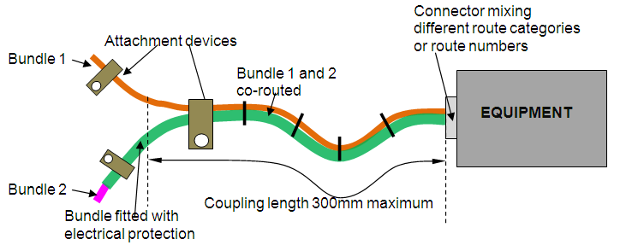

Figure 17. Co-routing at the back of mixed connector on equipment

*Note. Refer to SIDP92A001V-A-4556 for electrical protection of bundles..*

##### Minimum Clearances between Bundles Routed In Parallel

**General Clearances**

SIDP92A001V-A-941

*Minimum clearances detailed in table below shall be applied between parallel running bundles, when.*

* *both bundles are main longitudinal routes*

*OR*

* *when the maximum coupling length defined in relaxed requirements -1005, -1034, -1048, -1063, -1078 is exceeded (in this case clearances given in SIDP92A001V-A-941 do only apply on the length exceeding the maximum coupling length).*

*AND*

* *None of the considered bundle sections belong to "Main Transverse Routing"*

*Note 1. Clearances detailed in below table do not apply when both bundles match in route category and route number (e.g. 1M and 1MF)..*

**

Table 12. Minimum distances between parallel running bundles (general rule)

*Note 2. Clearances values marked with an asterisk (*) can be reduced down to 25 mm for G and X routes or 10 mm for other routes by using an electrical protection. Refer to SIDP92A001V-A-4556.*

##### Minimum Clearance between Crossing Bundles

A bundle crossing is a configuration where 2 bundles are crossing at 90° (±15°) as described in the figure below.



Figure 22. Definition of "Crossing Bundles"

## Installation of Connection Elements and Feed Through Seals

### Positioning and Selection of Connection Elements/Feed through Seals in the Aircraft Considering Environmental Constraints

The following chapter describes for connections elements (e.g. connectors, terminal blocks) and feed through seals such as pressure and fire seals.

- where to position them in the aircraft environment,

- how to orientate them (if applicable) and

- which type or standard to use for which purpose.

SIDP92A001V-A-5605

*Electrical active items shall not be positioned under removable (e.g. screwed) pipes couplings or under hydraulic equipment (e.g. hydraulic union).*

*Note. Crimped (swaged) pipe connections are not removable.*

In landing gear bays, connections between harnesses shall be reduced to the minimum and sealed.

#### Positioning and Selection of Connectors

**General**

Connector breaks of dynamic bundles (e.g. control actuator) should be located at a convenient point, as close as possible to the hinge, in order to simplify maintenance operations.

|  |  |  |  |  |
| --- | --- | --- | --- | --- |
| *xx* |  |  |  |  |
| *xx* |  |  |  |  |
| *xx* |  |  |  |  |

Table 62. Backshells for connectors

Connectors should not be installed vertically, as detailed in the figures below.



Figure 213. Rectangular connector positioning

Note. For protection of connectors, refer to chapter 7.3.4.

SIDP92A001V-A-5699

*Connectors shall not be installed between blankets and the skin of the aircraft.*

**Circular Connectors**

The main keyway of circular connectors should be at the top of the aircraft reference, as detailed in figure below. It should be specified in drawings. When the connector is installed in vertical axis (not recommended solution), the keyway should be at the aircraft forward reference.



Figure 214. Circular connector key way orientation

SIDP92A001V-A-5722

*Pin locking of connectors shall be ensured with N polarization as basic key way orientation. refer to connector standard.*

**Optical Connectors**

When installing optical cables, optical contact dimensions should be taken into account for connection positioning.

SIDP92A001V-A-5766

*A dummy optical receptacle (e.g. ABS0929-006) shall be installed near equipment on a bracket in order to connect the optical plug during maintenance.*

Note. Refer to chapter 7.2.6.6 for labelling of dummy receptacles.

**Other Connectors**

SIDP92A001V-A-5801

*When switch guard ASNE0419-A5 are used (e.g. on cockpit VUs), they shall be installed on the equipment and not on the switch itself.*

Harnesses connected to fuel probes and temperature sensors should use spade lugs or connectors. The use of ring lugs should be avoided due to FOD issues.

#### Positioning of Bonding/Current Return Brackets

SIDP92A001V-A-5861

*In hazardous areas and SWAMP areas (refer to zoning TN V92D06003716), bonding/grounding brackets shall be orientated as described in figure below.*



Figure 220. Orientation of bonding/grounding point brackets

### Attachment of Connections Elements/Feed through Seals to A/C Structure

This chapter describes principles applicable for attachment of connection elements (e.g. connector housings, relays, terminal blocks) as well as feed through seals (e.g. pressure or fire seal) to the aircraft structure.

SIDP92A001V-A-6318

*To attach connection items on metallic structure, one of the following principles shall be used, classified in order of preference. It is applicable to all routes.*



Table 66. Installation of electrical connections (VT or VC) on brackets on metallic surfaces

*Note. Refer to SIDP20A001V for bonding.*

#### Attachment of Connectors to A/C Structure

SIDP92A001V-A-6351

*In pressurized area, fixed circular connectors with square flanges - type EN3645 - shall be attached with two (minimum) diametrically opposed screws.*

SIDP92A001V-A-6362

*In non-pressurized area, steel or alloy connectors (type EN3645) shall be attached with four screws.*

## Installation of Electrical Equipment

### Positioning of Electrical Equipment in the Aircraft Considering Environmental Constraints

For positioning of equipment, the following should be taken into account.

- Equipment should not be installed in hazardous areas,



Figure 254. Positioning of equipment

- Heat dissipation of equipment should be considered,

In case this principle is in contradiction with any EIRD, priority shall be given to the EIRD.

SIDP92A001V-A-7762

*Inside small VU, cables/wires shall be sleeved with yellow ASNE0646 sleeve printed in black to identify PIN allocation as detailed in chapter 7.4.6, requirement SIDP92A001V-A-7749.*

*For safety cables/wires shall be fitted with a pink sleeve with PIN allocation printed in black.*

*This rule is not applicable to.*

*- Fixed cut-off connectors (VC),*

# Approval Sheet

|  |  |  |
| --- | --- | --- |
| **ISSUE** | **F** | |
| **DATE** | **July 2014** | |
| **FUNCTION** | **NAME** | **Siglum** |
| Document Author | xx | xx |
| Document Owner | xx | xx |
| Document Authorizer | xx | xx |
| Document Approvers. |  |  |
|  | xx | xx |
|  | xx | xx |
|  |  |  |
|  |  |  |
|  |  |  |

# Record of Revisions

|  |  |  |  |  |
| --- | --- | --- | --- | --- |
| Issue | Date | Effect on | | Reason for Revision |
| Page | Paragraph |
| A | 10 Apr 08 | All | All | Initial issue. |
| B | 06 Mar 09 | All | All | Revision Issue B. |

# Appendices

## Appendix A. Electrical Bundles Weight

The weight of electrical bundle is given in accordance with their route category, their diameter and the representative constituent material, for bundles without protection or cable ties.

● M route bundle weight can be estimated with M route bundle weight diagram.

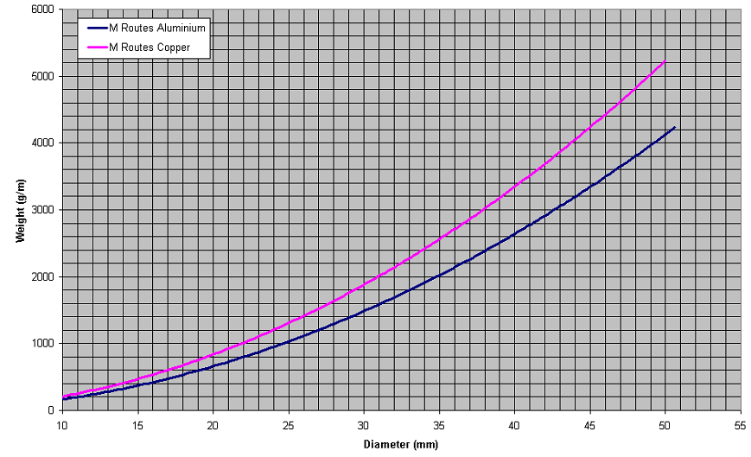

Figure 265. M route bundle weight diagram

## Appendix B. List of Approved Material, Standard Parts and Processes Prescribed

Refer to SSL LS0701118

## Appendix C. Clamp Size

Clamp size for NSA935805

|  |  |  |  |
| --- | --- | --- | --- |
| CONVOLUTED CONDUIT  NSA935805 | CLAMP  ABS1339 | CLAMP  NSA5516CBD  If ABS1339 can not be installed | CLAMP  ABS2195 |
| 04 | 01 | 04N | -04 |
| 06 | 02 | 07N | -07 |

## Appendix D. List of VU

List of VU. TBD

## Appendix E. Loss of Attachment Point

Visualization of "loss of attachment point"



## Appendix F. Mandatory Design Principles

All the requirements described in the SIDP92 are MANDATORY

**LIST OF DISTRIBUTION**

***To.***

SIGLUM - NAME, Surname

SIGLUM - NAME, Surname

SIGLUM - NAME, Surname

SIGLUM - NAME, Surname

***Copy.***

SIGLUM - NAME, Surname

SIGLUM - NAME, Surname

SIGLUM - NAME, Surname